***September Good News 2022***



**Our ministry vision for the Virginia Annual Conference is *“to be disciples of Jesus Christ who are lifelong learners, who influence others to serve.”***

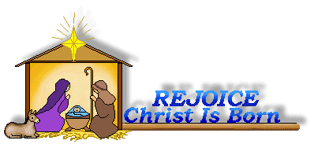

**From Pastor Adam**

*“Back to School”*

*Make me to know your ways, O Lord; teach me your paths.* (Psalm 25:4)

I write this article on the first day of school at VES. There are old and new faces – young people with the look of readiness for a new adventure. There is something in the air that says *“the days of learning have begun.”* Isn’t it interesting that we have grown to assume that learning ends the first week in June and picks up again in August with the start of the academic year? Yet the biblical tradition teaches us otherwise. It suggests that we are always and continuously growing in the knowledge and love of God. In the life of the Spirit, there is always a new discovery about the depth of God’s love, the breadth of God’s faithfulness, the reliability of God, and the peace of mind that comes in and through guidance of God’s commandments. In some sense, we are always “in school” as we journey with Christ in faith, and as we go, the Church becomes our classroom. The Psalms convey this sentiment as the word “teach” appears within them 32 times and the word “learn” another six times. Clearly, learning is a rich part of the Christian experience. So, what are we learning today? It’s a question worth our consideration.

God bless you my friends, Adam

**Choir News**

We will have choir practice on Thursday, September 1, at 6:30 p.m (subject to change). Come and lend your voice. All are invited!!

~**Heather Wilson, Director of Music**



**Circle News**

The **Merry Marthas Circle** will meet at church on Wednesday, September 14 at 10:00 a.m. We will have our UMW Pledge to Missions program and make our pledges for 2023. Please come prepared to pay your 2022 pledge if you haven't already. We will go to lunch at Charley's after the meeting.

~*Judy Robertson*

* * * * * * * * * * * * * * * * * * *

The **Wesleyan Group** will meet on Monday, September 12th, at 7:00 p.m., at the home of Ann Robbins.

*Mission Memo*

For the months of July and August our food basket contained 114lbs. of food and 4lbs. of hygiene products. Park View Mission was grateful for these donations and for our continued support of Food for Families. For September we will continue to collect canned meats and fruits. We will also collect Ravioli. Please make sure all the cans have tab tops. Thank you for the continued faithful support of this mission.

~*Thank you the Mission Committee*

**Food Cart...**

 Items needed for the Food Cart for ***Park View Community Mission.***

For the Month of  **September**

**Canned Meat, Canned Fruit and Ravioli**

*Place donations in the grocery cart, located in the Commons*. **No “*baked goods*” of any kind.**

*Place donations in the grocery cart, located in the Commons*

*Gifts & Memorials*

**In Memory:**

*Carolyn Stewart*

Given by: M. Brian & Paula Magargle,

Merry Marthas Circle

*Kathleen “Kitten” Boswell*

Given by: Robbie Perrow, Frances Unruh,

J. Owen Stinnette, Wilton & Kitty Burgess

**In Honor Of:**

*Robbie Perrow*

Given by: Judy P. Perrow & Family



*Chestnut Hill United Methodist Church extends Christian love and*

*sympathy* to the family of Kathleen “Kitten” Boswell and especially to her son, Kim. Mrs. Boswell passed away on July 21, 2022.

To Brenda Torian and Judy Martin on the death of their aunt, *Edith Barley*. Mrs. Barley passed away on August 13, 2022.

And to the family of *Tom Gordon* and especially to his sister, Kathy Comninaki. Mr. Gordin passed away on July 27, 2022.



**Mountain View District Palooza** (Annual Charge Conference) **-- Saturday, November 5th at 9:30 am at Amelon UMC, 220 Amelon Road, Madison Heights.**   
 (The District Office is asking for church buses or vans and offers of carpooling to transport church members to Amelon UMC. Be in touch if you can help).



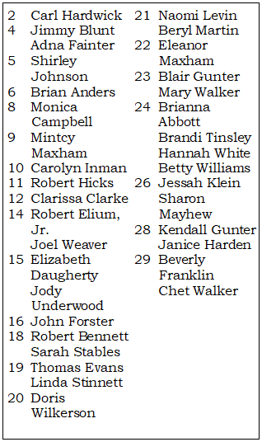

**2022**

|  |  |
| --- | --- |
| **Those Who Serve~September**  **GREETERS:**  September 4 ~*Tucker Cole*  September 11 ~*Jane White*  September 18 ~*Mary Walker*  September 25 ~*Betty Taylor*  + + + + + + + + + + + + + + + + + + + + + + +  **GOOD NEWS** is published monthly for members and friends of Chestnut Hill United Methodist Church. Send articles to the church office by the 15th of the month. **(Subject to change.)**  + + + + + + + + + + + + + + + + + + + + + + + | **Our Church Financial Picture**  Through the end of July 2022  General Operating Funds:  Needed to meet our 2022 Budget $ 194,759.00  Needed to meet our budget to date $ 113,609.00  Actual receipts to date $ 103,487.00  Shortage to meet budget to date $ 10,122.00  Actual expenditures to date $ 96,665.00  Overage to meet expenses to date $ - 6,822.00  Joy In Missions Funds:  Our Giving Goal for 2022 $ 11,600.00  Needed to meet our goal to date $ 6,767.00  Actual receipts to date $ 5,910.00  Special Offerings* (not budgeted):  Received to date $ 12,850.00  Dispersed to date $ 12,430.00  *Christmas, Easter, Annual Conference,  World Communion, etc.  **2022 Joy In Mission Donations**  To date, the following amounts have  been paid to the missions indicated.  Budget Spent  1. Missionary Covenant Relationship $1,000 $500  2. Interfaith Outreach $1,000 $500  3. Park View Mission, Food for  Families $3,000 $1,825  4. Society of St. Andrew $1,000 $500  1. Adult Care Center $ 500 $250  2. Blue Ridge Area Food Bank $ 1,000 $500  3. Camp Timothy $ 500 $500  4. Churches for Urban Ministry $ 500 $0  5. Daily Bread $ 500 $250  6. Free Clinic $ 500 $250  7. Good Neighbor $ 500 $0  8. Habitat for Humanity $ 500 $250  9. UMCOR-Non-Administrative $ 500 $0  10. Undesignated $ 600 $0  Thank You for Your Generosity |

**March 2022**



January 2022

**2022**



**April 2022**

**April 2022**

**March 2022**



*Chestnut Hill United*

*Methodist Church*

4660 Fort Avenue, Lynchburg, VA 24502

Phone Number: 434-239-8423: FAX: 434-239-7209

E-mail: [chestnuthillumc@comcast.net](mailto:chestnuthillumc@comcast.net)

On the web: www.chestnuthillumc.net

Church Office Hours

**Monday-Thursday~**9:00 am—3:30 pm

**Friday~**9:00 am-1:00 pm

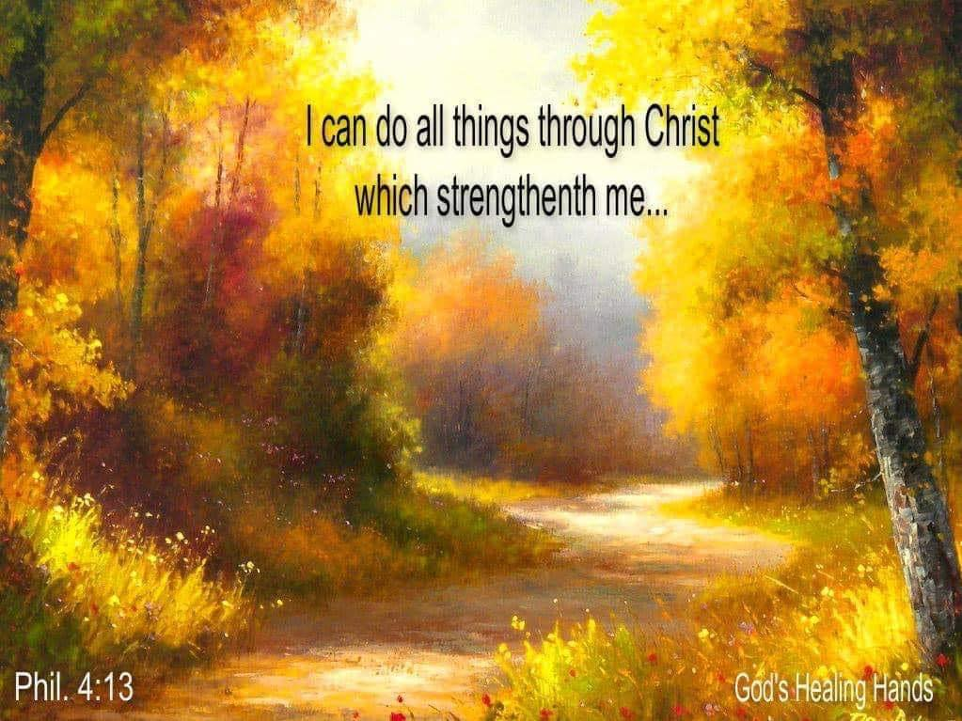

***DIRECTORY OF***

***CHESTNUT HILL UNITED METHODIST CHURCH***

|  |  |  |
| --- | --- | --- |
|  | Sharma Lewis | Richmond Area Resident Bishop |
|  | Denise Bates | Lynchburg District Superintendent |
|  | Adam White | Minister |
|  | Erin Long | Associate Minister |
|  | Monica C. Campbell | Administrative Assistant |
|  | Heather Wilson | Director of Music Ministry |
|  | Judy Martin | Bookkeeper |
|  | Judy Robertson | Lay Leader |